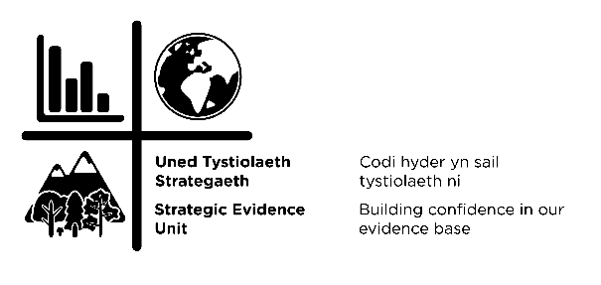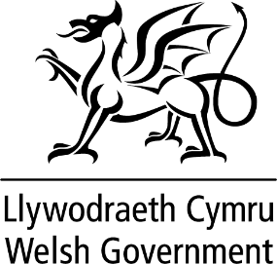

Social Transformation and Behaviour Change

Fellowship Opportunity

Welsh Government are inviting proposals for a Social Transformation and Behaviour Change Fellowship role, working within the Environment and Rural Affairs (ERA) Department. This position aims to support the development and understanding of social science and behaviour science in systems thinking across the department.

This position will work in a multidisciplinary evidence team supporting a wider programme to contribute to delivering robust, evidence-based decisions within Welsh environment and agriculture policy. The team works through research collaboration with policy, business and land management partners to deliver desired policy outcomes.

Applications are invited for proposals from Post-doctorate Researchers to Senior Researchers and the role is open to candidates to create their own proposal for how a placement may function. The Welsh Government is able to support this as a part time or full time role.

The outcomes of activities undertaken during the Fellowship are expected to lead to new and improved understanding from the synthesis of research from social and behaviour science and the uptake of research outcomes in policy- making and applications, and new and innovative methods for participatory and inclusive decision processes.

All applicants must be employed by an eligible host organisation for the duration of the Fellowship to receive funding. Eligible host organisations include UK Higher Education Institutes, eligible Independent Research Organisations or Public Sector Research Establishments (PSREs).

HOST ORGANISATION DETAILS AND OUTLINE OF ROLE ON OFFER:

Organisation name | Welsh Government - Environment and Rural Affairs (ERA) Department
Role description | Social Transformation and Behaviour Change Fellowship - focusing on sustainable social change and understanding behavioural responses to change.
Proposed start date | August/September 2021
Duration of placement | 12-18 months
Funding | Welsh Government will provide funding equivalent to candidate’s employment with their academic institution, to a maximum budget of £80,000.
Working schedule | The host is flexible regarding this aspect and can be negotiated to ensure best fit for both host and researcher.
Summary of the Fellowship – Purpose:
It is a time of momentous change within Governments in the UK. Leaving the EU gives Governments the opportunity to chart their own path. However, all UK Governments are dealing with impacts and the aftermath of a pandemic and a looming climate emergency. All of these factors and limited resources, means that Governments need to be more focussed and the need to deliver policies that are effective has never been greater.

In this environment of great change, Welsh Government is seeking to recruit a social science / behavioural science expert to advise and guide policy makers in creating focussed and effective policy implementation.

Behavioural and social change is required in a range of contexts and roles, from Welsh Government institutional change, to citizen and consumer choices, to professional and business choices. An understanding of societal drivers of change and behaviour responses to those changes will improve and help make policy changes more effective.

Policy development works in a cycle and policy teams across the department are at different points within this cycle.

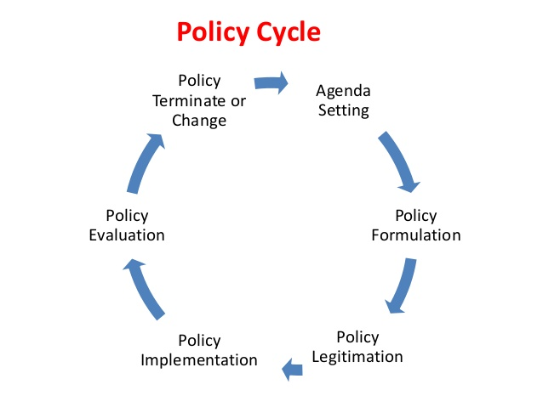
The Fellow will have the opportunity to engage with policy teams at development, implementation and evaluation of a wide range of policies. The department requires advice and guidance on subject areas covered by both social science and behavioural science, the candidate can be a specialist in either discipline, but may be asked seek out information or expertise on the other discipline to cover the breadth of the work of the department.

Outline of position and types of projects and activities the position could be engaged with:
The Fellow will be embedded within the Strategic Analysis branch within the ERA Strategic Evidence Unit. The Fellow will work as a member of this team providing behavioural/social science insight and evidence to cross departmental strategic projects.

The Fellow will deliver wider engagement with policy colleagues across Welsh Government via the behavioural science network and by working closely with the Welsh Government Sustainable Development Change Manager:

- To promote knowledge exchange between the social/ behavioural science academic community and ERA;
- To provide ERA with social/behavioural science input into developing evidence to inform policy;
- To develop a best practice model to embed social science into the policy developmental and evaluation cycle;
- To provide the researcher and research community with a wider context for their research.
When providing social and/or behavioural science input into policy development the Fellow would:

- Act as an expert scientific advisor on social science/ behavioural science to Policy teams, advising them and assisting them to consider how to use behavioural or social science insight to improve the performance of policies and interventions.
- Undertake a review of social and behavioural science evidence capability and use across the department. Identifying evidence gaps and opportunities for better collaboration across the department in use and commissioning of behavioural science insight.
- Working with the internal Behaviour Change Programme in co-ordinating communities of practice and supporting behaviour change networks to help build social science / behavioural science capability within Welsh Government.
- Provide written analysis and research evidence on social science and behavioural science to support Policy development.
- The types of projects policy teams in the department are currently involved in include:
- Water Efficiency Group - on improving water efficiency behaviours.
- Biodiversity Task Force - in mainstreaming biodiversity in policy thinking and public awareness.
- Sustainable Farm Scheme Policy Team - in using behavioural science to improve scheme uptake and delivery.
- Food Team and Food Insight contractors - to develop evidence to support insights into consumer behaviours and trends and translating this into policy ideas.
- Circular Economy Team - on embedding circular economy behaviours.
- Including behavioural science in land use change modelling.
Expected benefits for successful applicant:
This is a unique opportunity to work within Government to influence and shape the use of social science and behavioural science in policy-making. It offers the opportunity to demonstrate the impact of social and behavioural sciences by directly applying them to policy and how it can improve outcomes.

The position also offers the opportunity to develop an integrated programme of behaviour change work in a context where there is already infrastructure in place and a desire for collaboration from policy leads across a range of policy areas (climate change, biodiversity, air quality, transport, public health, etc.) to support key Government priorities.

The scope of work will lead to experience of:

- Input into emerging policy development focusing on a green recovery;
- Input into a programme of work on behavioural mechanisms to contribute toward net zero;
- An understanding of the policy making process and the role of evidence within it;
- Expertise on generating and translating behavioural science for policy makers;
- Direct influence on the generation of new policies, standards and regulations in Wales;
- Experience of working with policy decision makers and Ministers;
- Opportunities for in-house training and development;
- Working with a diverse group of stakeholders from government, regulators, industry and the third sector.

External Stakeholder Engagement:
As part of the Fellowship you would be expected to engage with UK Government, particularly BEIS (Department of Business, Energy & Industrial Strategy) and DEFRA (Department for Environment, Food & Rural Affairs) and Devolved Administration departments as well as colleagues in public and regulatory bodies such as NRW (Natural Resources Wales).

Liaison with academia via you own networks and the Environment Platform Wales would also be expected. We anticipate that the first phase of this work will lead to a number of more detailed areas of focus (some of which may be taken forward by the same Fellow). These would require more direct engagement with organisations instrumental in delivery.

Welsh Government (WG) support:
Given the current situation with regards to WG Covid-19 Guidance, this role will be required to be carried out remotely. As and when appropriate health & safety requirements allow, attendance at meetings in the main WG office in Cathays Park, Cardiff, and/or regional office locations across Wales (partly depending on the successful candidate’s location) may be required.

Access to relevant WG advisors, analysts and policy colleagues will be available to support this role, as well as access to cross UK Government behavioural science networks.

Fellowship outputs:
In the first 2 months of the role, the candidate will be expected to develop a programme plan of work and agreed outputs for the contract period. It is expected there will be a certain amount of flexibility in the programme to accommodate priority shifts.

The successful candidate will report and discuss progress to the steering group on a monthly basis.

The role is required to undertake a review of the evidence needs of the department in the fields of both social and behavioural science, including identifying capacity and capability gaps.

This role is expected to submit one or more research publications as first author to peer-reviewed journals resulting from the research synthesis undertaken through their fellowship.

The successful candidate could address a number of challenges, for example:
- Improve understand how individual, public or organisation respond to policy interventions;
- Review frameworks or methodologies to embed social and behavioural science into policy design and evaluation;
- Develop options or models for improving the impact of policy interventions within WG;
- Translating policy needs into research questions;
- Interpreting and communications science to non-specialist.
Research synthesis activities should review research outcomes and insights from different disciplines from within and beyond social science / behavioural science and reflect on policy or intervention recommendations and/or academic breakthroughs in our understanding of decision-making processes for multifunctional outcomes.

HOW TO APPLY
Applicants should submit the following 4 documents to the Welsh Government Environmental Evidence Mailbox environmentalevidence@gov.wales
- A covering letter (maximum one side of A4) outlining why you are applying for the post and what you will bring to the role.
- Project proposal (maximum two sides of A4) outlining how you envision the fellowship, the opportunities and the areas of research you would seek to develop.
- Curriculum Vitae (maximum two sides of A4).
- A letter from your academic institution. This needs to state how it will support your release from teaching and administrative duties, as necessary, and provide formal acceptance of the conditions of the scheme.

Deadline:
The deadline for submitting the above documentation is 14:00 29 June 2021.
Question deadline 14:00 14 June 2021.

Criteria:
- Awareness of Welsh policy landscape and devolution
- Track record in undertaking behavioural or social science research projects
- Ability to write concise reports
- Ability to present research findings succinctly
- Ability to communicate in Welsh an advantage but not essential.
Applicants can be at any career stage but are expected to have a PhD by the start date of the Fellowship position, or be able to demonstrate equivalent professional experience gained in a stakeholder organisation. Applicants with a permanent academic position (or equivalent in institutions other than universities) are also eligible.

The Fellowship applicant must be the Principal Investigator and may only submit one proposal to this call. Co-Investigators or other named researchers are not eligible.

Welsh Government Commitment
Equality:
It is our policy to promote and integrate equality of opportunity into all aspects of our business including appointments. We welcome applications from individuals regardless of age, marriage (including equal/same sex marriage) and civil partnership, sexual orientation, sex, gender identity, disability, race, religion or belief or pregnancy/maternity.

If you have an impairment or health condition, or use British Sign Language and need to discuss reasonable adjustments, or wish to discuss how we will support you if you are to be successful, please contact Head of Strategic Analysis Ann Humble by email: ann.humble@gov.wales as soon as possible to discuss your requirements and any questions you may have, before the Question Deadline 14:00 14 June 2021.

Welsh Language:
The Welsh Government is a bilingual organisation and Welsh language skills are considered an asset to the organisation. We encourage and support the use of individuals Welsh language skills.

General Data Protection Regulations (GDPR):
This privacy notice tells you what to expect when you contract the Welsh Government and provide us with your personal information: https://gov.wales/welsh-government-privacy-notice#section-8567 All of the information you provide during this selection process will only be used for the purpose of progressing your application, or to fulfil legal or regulatory requirements if necessary.

ASSESSMENT PROCESS
The assessment process for applications to this call will be considered using a two-stage assessment process.

All applications received will be assessed by independent experts at a sift panel. An expert panel of Government researchers and users will review submitted applications and make recommendations on those suitable to progress to stage two. Applicants will be notified whether or not their application will progress to the second stage.

For applications put forward to the second stage the applicants will be invited to an interview panel, where they will have the opportunity to present their fellowship proposal and discuss with and answer questions from the panel. This will be undertaken via the Microsoft Teams platform to enable us to adhere to the latest Covid-19 Guidance. It is anticipated that these virtual interviews will take place the weeks commencing 12 & 19 July 2021.

The assessment criteria to be used are detailed below:

- Excellence of Proposal – quality and novelty of the proposed research synthesis, research translation or community engagement activities
- Suitability of Applicant – relevant experience and potential of the applicant, potential benefit of fellowship for their career development/transition
- Fit to Scheme

Feedback will be provided to both successful and unsuccessful applicants following the stage of assessment at which a decision is made concerning their application
WG will use the recommendations of the interview panel along with the overall call requirements and the available budget in making the final funding decisions.
WG reserve the right to use the recommendations to create a balanced portfolio for this Fellowship opportunity.
WG Vetting Checks will be required to be carried out with the successful candidate prior to any appointment being made.

FOR FURTHER INFORMATION AND BACKGROUND READING:
Please contact Head of Strategic Analysis Ann Humble by email: ann.humble@gov.wales before the Question Deadline 14:00 14 June 2021.
Useful documents to consider (not exhaustive):
https://gov.wales/written-statement-brexit-and-our-land-summary-responses-and-our-response
https://gov.wales/agriculture-wales-bill
https://gov.wales/low-carbon-delivery-plan
https://gov.wales/nature-recovery-action-plan
https://gov.wales/evidence-and-scenario-sub-group-roundtable-wales-and-brexit
https://gov.wales/circular-economy-strategy
https://www.chathamhouse.org/2021/02/food-system-impacts-biodiversity-loss/02-how-todays-food-system-drives-biodiversity-loss

The role of the Welsh Government Sustainable Development Change Manager: https://academiwales.gov.wales/pages/quick-tips-awgrymiadau-cyflym

