Document History

Environment and Communities Division,
Welsh Government
Welsh Government Clean Air Advisory Panel

Terms of Reference

Summary

Status | Final
Version | 1.0
Date | 18 December 2019
Owner | Terri Thomas
Author | Roger Herbert
Approved by | Project owner
Summary | Welsh Government Clean Air Advisory Panel terms of reference.

Revision History
Version Number | Date |  | Comment | By |  | Approved
0.1 | 19 July 2019 |  | Interim draft | Roger Herbert
0.2 | 10 December 2019 |  | Interim draft | Roger Herbert
1.0 | 18 December 2019 |  | Final draft | Roger Herbert
Distribution
Name |  |  | Title |  | Date of Issue |  | Version
Welsh Government Clean Air Programme Board |  |  | Welsh Government Clean Air Advisory Panel terms of reference

Table of Contents
Document History 0
Summary 1
1 Purpose 3
2 Role of the Panel 5
3 Support 5
4 Meetings / Discipline 6
5 Venue 6
6 Panel Membership 6
7 Roles and Responsibilities of Panel members 6
7.1 Senior Responsible Owner (SRO) 6
7.2 Project Manager 6
7.3 Other Panel attendees 7
8 Required Commitment of Membership 7

Purpose

The Clean Air Advisory Panel will provide evidence-based advice and recommendations to the Welsh Government Evidence, Innovation and Improvements Project Team on air quality matters in Wales, helping to underpin the decision making of the Welsh Government Clean Air Programme Board. The Panel will support Welsh Government in seeking to enhance the understanding of airborne pollution in Wales in order to support the development of policy and to drive improvements in air quality in Wales where they are needed the most. Membership of the Panel will consist of multi-disciplinary policy makers, academia and air quality and public health practitioners.

The Clean Air Programme brings together a wide range of Welsh Government departments and public bodies across the relevant sectors. The Programme’s focus is on the requirement to comply with international, European and domestic legislative air quality obligations, and to reduce the burden of poor air quality on human health, biodiversity and the natural environment by reducing exposure to pollution more widely.

The Welsh Government’s draft Clean Air Plan for Wales is a key product of the Programme which sets out wide-ranging actions to improve air quality in Wales. Welsh Government is committed to developing more granular air quality evidence, supplementing existing information, to support policy and legislative development in Wales. The advice of the Panel will support both the development and the delivery of this work. Key evidence based commitments in the Plan requiring specific focus include:

- to develop and consult on new evidence-based, health-focused, targets for particulate matter in Wales which take account of the World Health Organisation guideline values;
- to develop a new Clean Air Act which enhances existing legislation and brings forward new legislation to deliver air quality improvements in Wales;
- to enhance the monitoring and assessment capabilities regarding air quality and the associated risks in Wales; and
- to establish a new national air pollution monitoring network which complements existing monitoring capabilities, primarily focusing on sensitive receptor locations in Wales.

The figure below illustrates the role of the Panel:
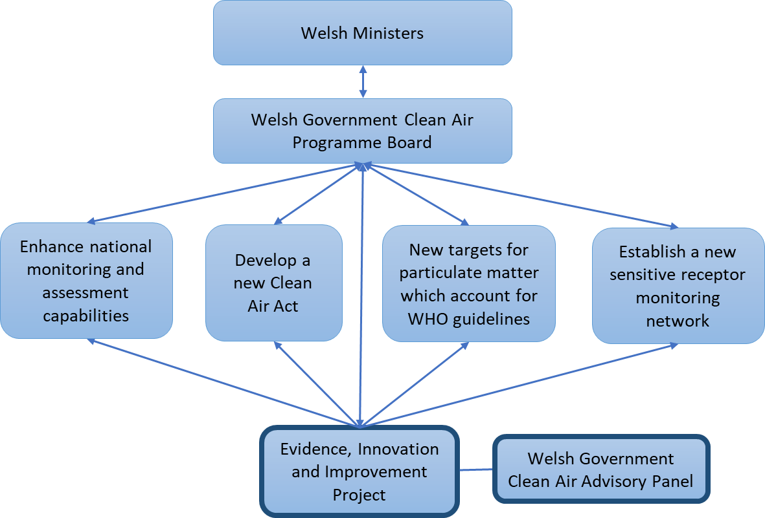

Panel members are expected to work within the context of the obligations under the Well-being of Future Generations Act 2015. This Act is intended to ensure public bodies think more about the long term, work better with people and communities and each other, look to prevent problems and take a more joined-up approach. It places a duty on all public bodies in Wales to consider how their actions might impact in the long term, and how they will alleviate problems of poverty, health inequalities and climate change.

The Panel will deliver work in line with the Act’s five ways of working by:
- establishing evidence to support the development of long-term targets for the progressive reduction of air pollutant emissions and ambient concentrations;
- improving the integration of air quality evidence provision through improved working practices between public and third sector organisations;
- involving stakeholders in the development and delivery of the project at all stages;
- collaborating with relevant departments within Welsh Government, UK Government and at a local level to ensure well-being objectives are met; and
- focusing on evidence to underpin the development of positive actions which help to prevent any future increases in the impacts of airborne pollution on the health of the Welsh people.

It will be important to consider fully the impact of current and future evidence required to support the delivery of Welsh Government’s well-being objectives set out in Prosperity for All, and their impact on all of the well-being goals set out in the Well-being of Future Generations legislation. They should be considered alongside the impact of the proposed commitments described in the draft Clean Air Plan for Wales.

Role of the Panel

The Panel members are expected to work collaboratively to provide the advice and actions necessary to support the aim of the Clean Air Programme for Wales.

Members are required to:

- Independently advise on and provide scientific evidence to support the development of Welsh Government clean air policy.
- Advise on current evidence in relation to air quality and its relationship with associated environmental, public health and economic factors.
- Work collaboratively across government, industry and academia, to ensure actions taken to improve airborne pollution in Wales are based on robust evidence.
- Encourage and maximise opportunities for innovative solutions which help to improve levels of airborne pollution.
- Advise the Welsh Government on future evidence needs and how they can be met.

To be achieved by:

- Developing and sharing a better understanding of air quality issues, evidence and policy requirements across Wales and the UK.
- Ensuring all parties have the opportunity to advise on possible means of resolving or minimising these issues and maximising potential opportunities for collaboration and innovation.
- Providing judgements on quality and relevance of evidence and research, suggesting priority areas for future work and advising on how they should be implemented to achieve greatest benefit.
- Ensuring the right level of evidence is available to enable actions to monitor, assess, model and reduce levels of air pollution in Wales, as appropriate.
- Providing ad-hoc advice when specifically requested.
- Identifying the important questions for consideration and collaborate with other external experts.

Support

An agenda will be circulated to all members by the Welsh Government’s Evidence, Innovation and Improvement Project Team prior to each meeting and meeting notes will be distributed to all members after each meeting.

Reasonable expenses, including travel and in certain circumstances overnight subsistence allowances, will be considered on case by case basis. All travel and subsistence claims will be subject to current Welsh Government rules and paid at current Welsh Government rates.

Meetings / Discipline

The Panel will:

- Hold quarterly meetings to discuss current and future evidence requirements in support of government policy development and improvements in airborne pollution.
- Ensure the correct priorities have been identified for action.
- Discuss progress against the project’s objectives and help identify remedial actions where progress is slow.
- Ensure any shared official-sensitive information is handled appropriately, and is not disclosed outside of the Panel’s membership.
- Agree meeting dates at least 3 months in advance.
- Deputies will only be allowed with prior agreement.

Venue

- Meetings will usually be held at Welsh Government, Cathays Park, Cardiff.
- It may be possible for panellists to use teleconferencing to join a meeting if they are not able to attend in person. Panellists can still provide written comments if they are unable to attend.

Panel Membership

Panel members will have a range of expertise including in the fields of air quality (monitoring, modelling or policy), public or environmental health assessment relating to air quality, industrial regulation, transport policy or planning.

The cross-sectoral membership will be circulated once those invited have confirmed their willingness to participate.

Roles and Responsibilities of Panel members

The Panel members are advisers, helping to ensure that the project remains on course, capable to deliver the desired outcomes and is of the required quality.

Senior Responsible Owner (SRO)

The SRO is the ultimate decision maker for the project, having taken into consideration all panel members’ thoughts and advice.

Project Manager

The Project Manager is accountable to the SRO and will manage the running of the Panel. The Project Manager will provide advice, guidance and recommendations to the SRO, including the advice of the Panel. The prime responsibility is to ensure that the project produces the required products, to the required standard, on time and within budget.

Other Panel attendees

The Project Manager may invite other attendees to the Panel to report on areas of responsibility and/or provide advice and guidance. These attendees do not form part of the Panel membership.

Required Commitment of Membership

Panel members will be required to:

- Attend panel meetings (quarterly & special meetings as necessary).
- To review and comment on relevant papers or reports identified by the Panel and deliverables provided to the Panel by the project team.
- Undertake off-line reviews and collaborative work, as required by the project, in order to facilitate prompt decision making.
- Make any declaration of interest in the event of a conflict between the deliberations and actions proposed by the Panel and the interest or activities of the individual’s employer, whether commercial or otherwise.
- Deputies will not be permitted to attend panel meetings without prior agreement of the SRO.

Clean Air Plan for Wales, Healthy Air, Healthy Wales https://gov.wales/clean-air-plan-wales

